**Documentation of Salary-api (OT-MICROSERVICES)**

1. After creating an instance, first is to update the packages (instance type t2.large volume 20GB)

**sudo apt update**

1. Now, clone the salary-api repo in your instance

**git clone** [**https://github.com/OT-MICROSERVICES/salary-api.git**](https://github.com/OT-MICROSERVICES/salary-api.git)

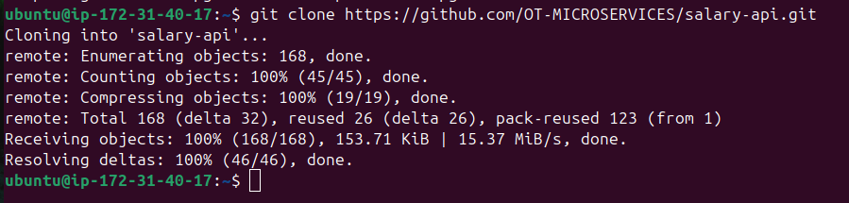

1. Now, install all the prerequisites required for salary-api
   1. Scylladb Installation and configuration

* + 1. Install a repo file and add the ScyllaDB APT repository to your system.

**sudo mkdir -p /etc/apt/keyrings**

**sudo gpg --homedir /tmp --no-default-keyring --keyring /etc/apt/keyrings/scylladb.gpg --keyserver hkp://keyserver.ubuntu.com:80 --recv-keys A43E06657BAC99E3 491c93b9de7496a7**

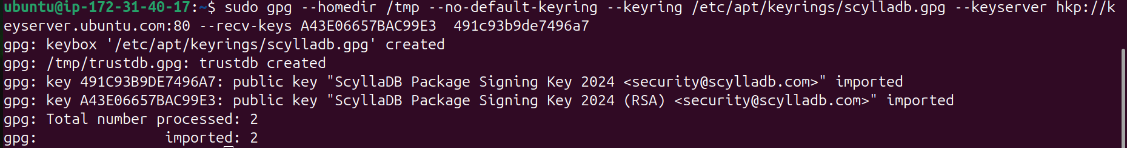

**sudo wget -O /etc/apt/sources.list.d/scylla.list** [**http://downloads.scylladb.com/deb/debian/scylla-6.2.list**](http://downloads.scylladb.com/deb/debian/scylla-6.2.list)

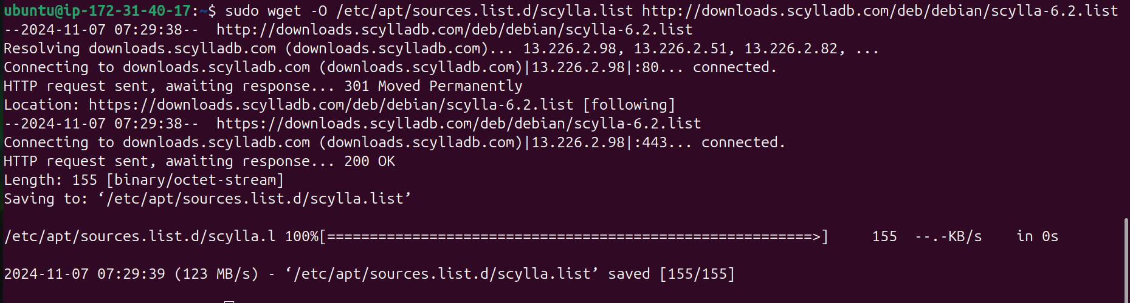

2) Install ScyllaDB packages.

**sudo apt-get update**

**sudo apt-get install -y scylla**

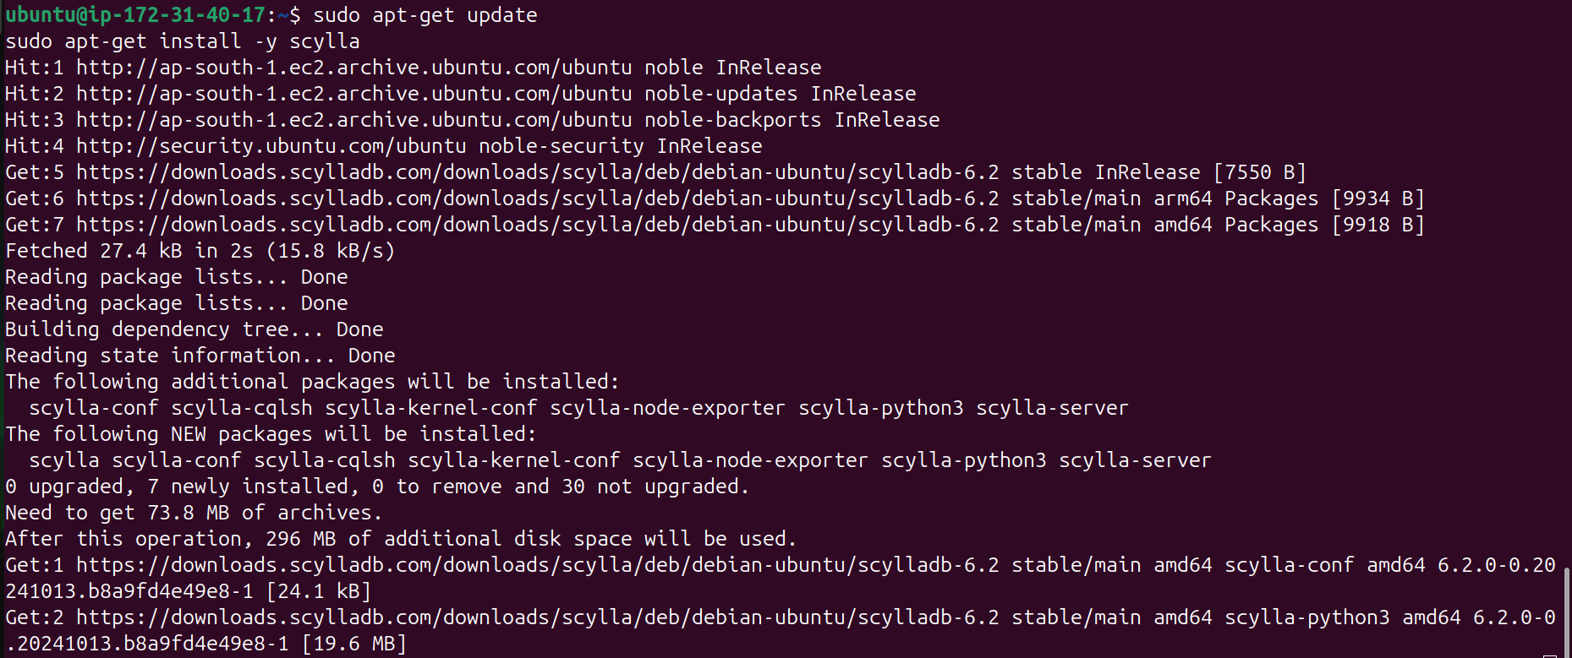

3) Configure I/O settings for ScyllaDB on your VM.

**sudo /opt/scylladb/scripts/scylla_io_setup**

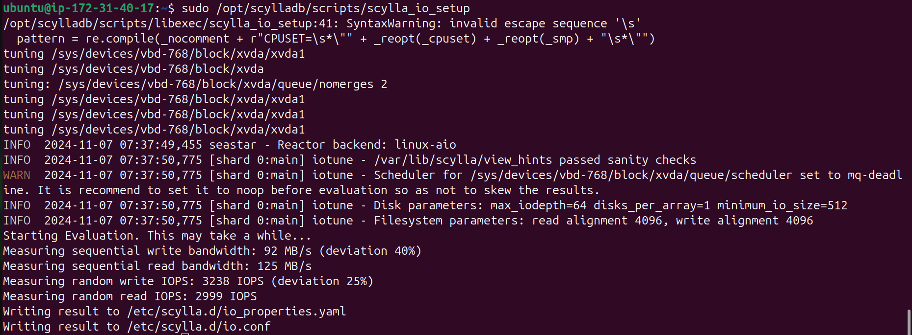

4) In the configuration file of scylla do the following changes

Path of scylla.yaml:-**yes  
 sudo /opt/scylladb/scripts/scylla_io_setup**

1. Add this line for access control and permission

**Add the below in first line of above file**

**authenticator: PasswordAuthenticator**

**authorizer: CassandraAuthorizer**

b) Now mention rpc address (Your Private IP)

**rpc_address: 172.31.40.17 (line 222)**

**The rpc_address defines the IP address that clients (such as application servers or other services) should use to connect to the ScyllaDB node.**

**Clients communicate with the database cluster through this address, making it crucial for client-server communication.**

5) Restart the scylla-server service

**sudo systemctl restart scylla-server.service**

6) Now enter into scylladb using below command

**cqlsh 127.0.0.1 9042 -u cassandra -p cassandra**

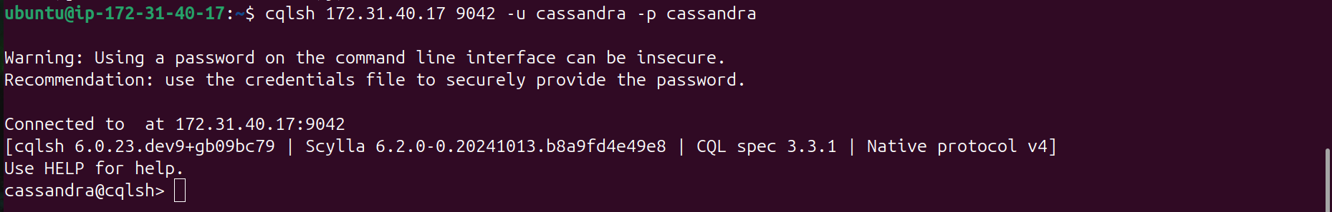

7) Create user ‘scylladb’ with password as ‘password’

**CREATE USER scylladb WITH PASSWORD 'password' SUPERUSER;**

8) Check users list in scylladb

**LIST USERS;**

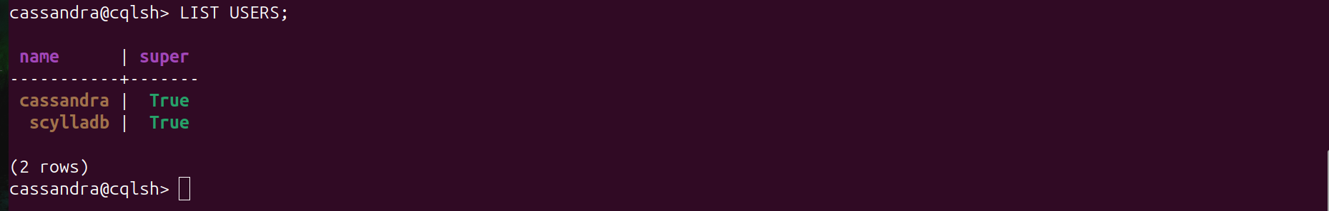

9) Create keyspace employee_db

**CREATE KEYSPACE employee_db WITH REPLICATION = { 'class': 'SimpleStrategy', 'replication_factor': 1 };**

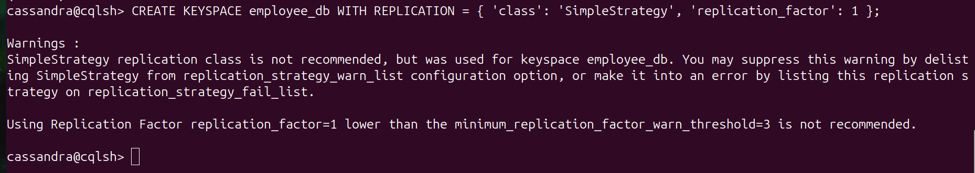

**10)** Check whether the employee_db

**DESCRIBE KEYSPACES;**

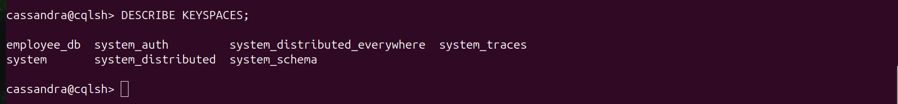

**Data base dekhana ho to**

**11) USE employee_db ;  
12) DESCRIBE TABLES;**

**13) SELECT * FROM employee_info ;**

**Salary ke liye :**

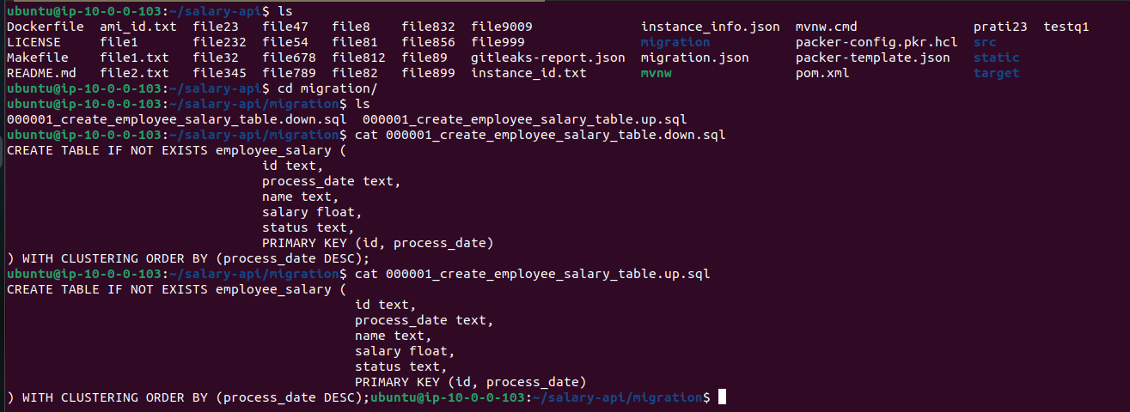

**B) Redis Installation and Configuration**

1. Install redis

**sudo apt update**

**sudo apt install redis-server -y**

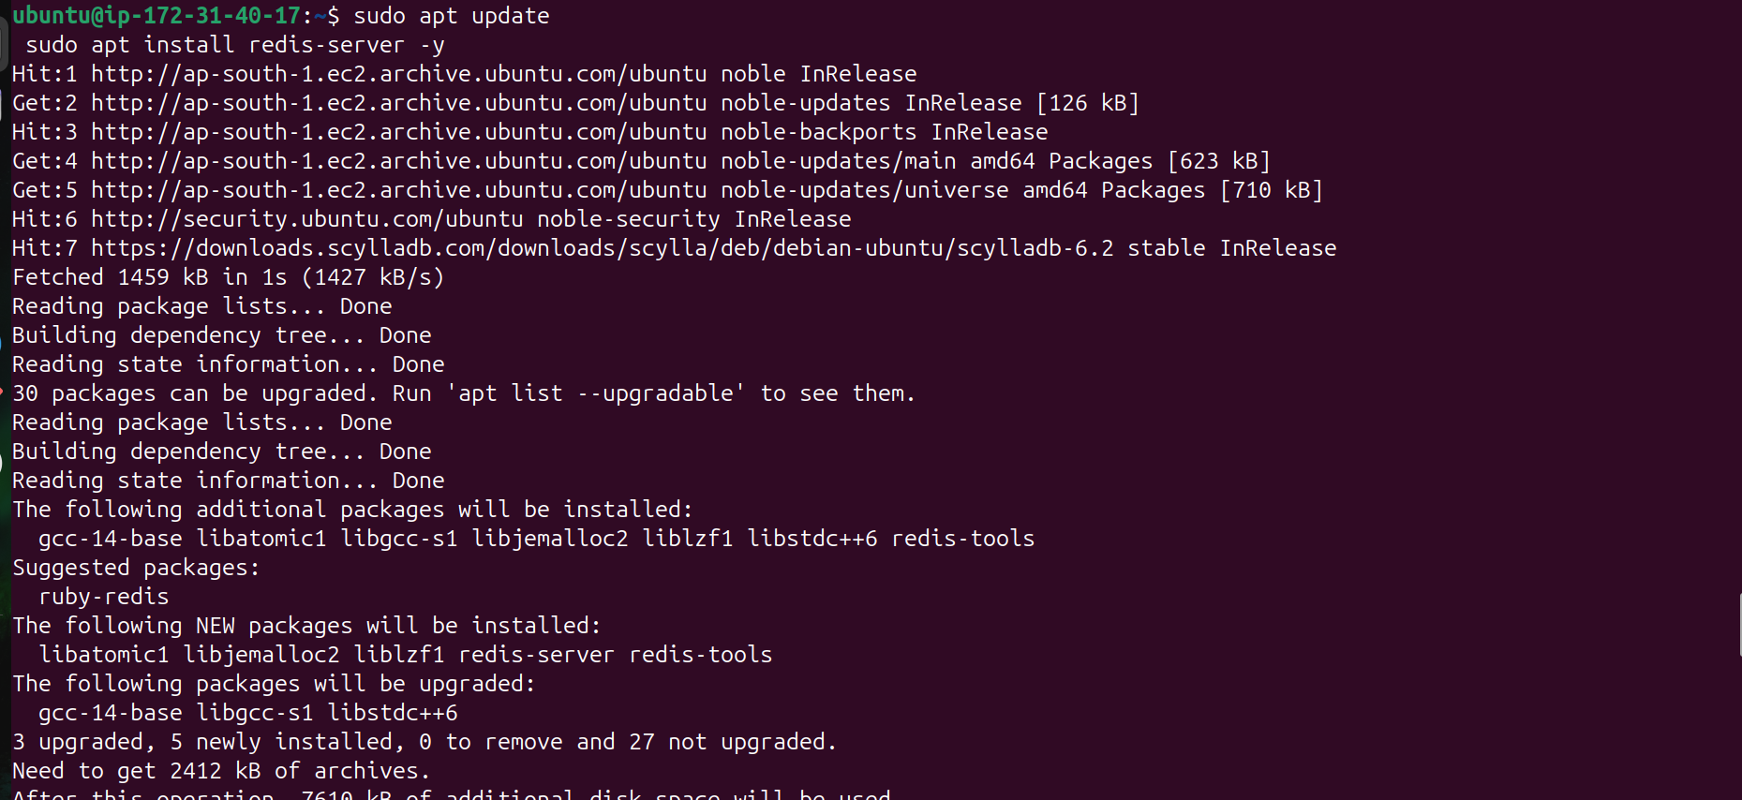

1. Configuration of redis : Enter into redis

**redis-cli**

3) Configure user permissions and authentication settings in redis

**ACL SETUSER scylla on >password ~* +@all**

4) List the acl to check whether it is updated or not

**ACL LIST**

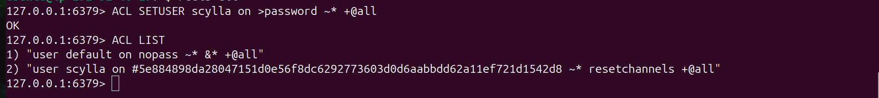

**C) Install Maven**

1. Now install maven using below command but before that install java 17

**sudo apt update**

**sudo apt install openjdk-17-jdk -y**

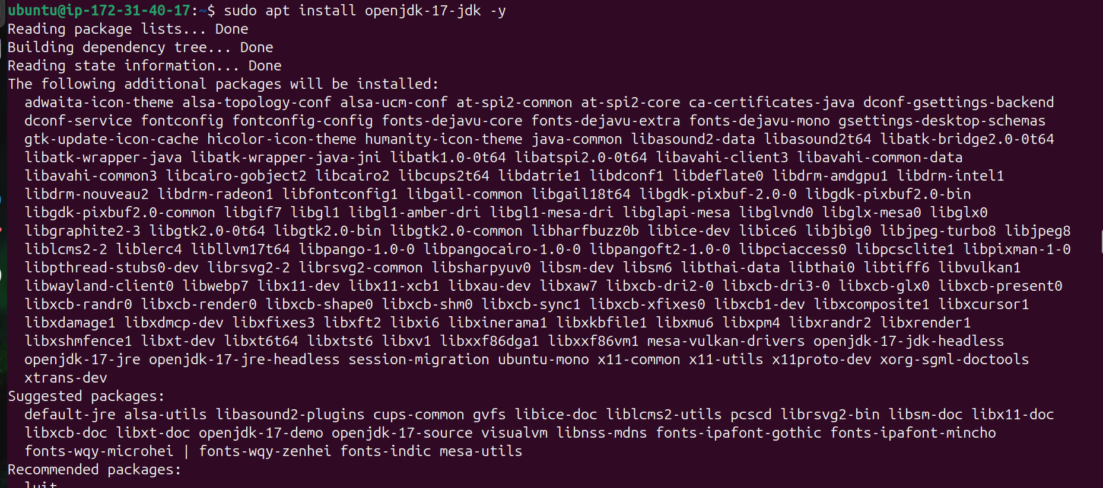

**sudo apt install maven -y**

1. Enter into salary-api directory and change the ip address in application.yaml to your private ip address

1. **Enter into src/main/resources/**

**cmd: - sudo vi src/main/resources/application.yml**

1. **Enter into src/test/resources/**

**Cmd: -sudo vi src/test/resources/application.yml**

3) Create the service file for salary-api service

Path: - **sudo vi /etc/systemd/system/salary-api.service**

**The service file is as follows**

[Unit]

Description=salary api

After=network.target

[Service]

Type=simple

User=ubuntu

Group=ubuntu

WorkingDirectory=/home/ubuntu/salary-api/

ExecStart=java -jar /home/ubuntu/salary-api/target/salary-0.1.0-RELEASE.jar --server.port=8081

Restart=on-failure

RestartSec=5

StandardOutput=journal

StandardError=journal

[Install]

WantedBy=multi-user.target

4) Enable and start the salary-api service

**sudo systemctl enable salary-api.service**

**sudo systemctl start salary-api.service**

4) Restart the salary-api service

**sudo systemctl restart salary-api.service**

**D) Install migration tool**

1. Download the zip file of the migration tool(migrate)

**curl -L https://github.com/golang-migrate/migrate/releases/download/v4.15.2/migrate.linux-amd64.tar.gz | tar xvz**

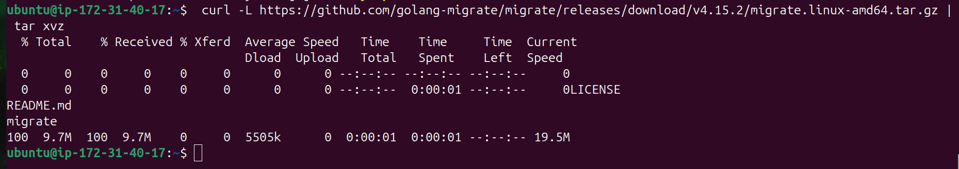

1. **Move the file to below location**

**sudo mv migrate /usr/local/bin/migrate**

1. Check the version of migrate

**migrate --version**

E) Now enter into salary-api directory and run the clean package

**mvn clean package**

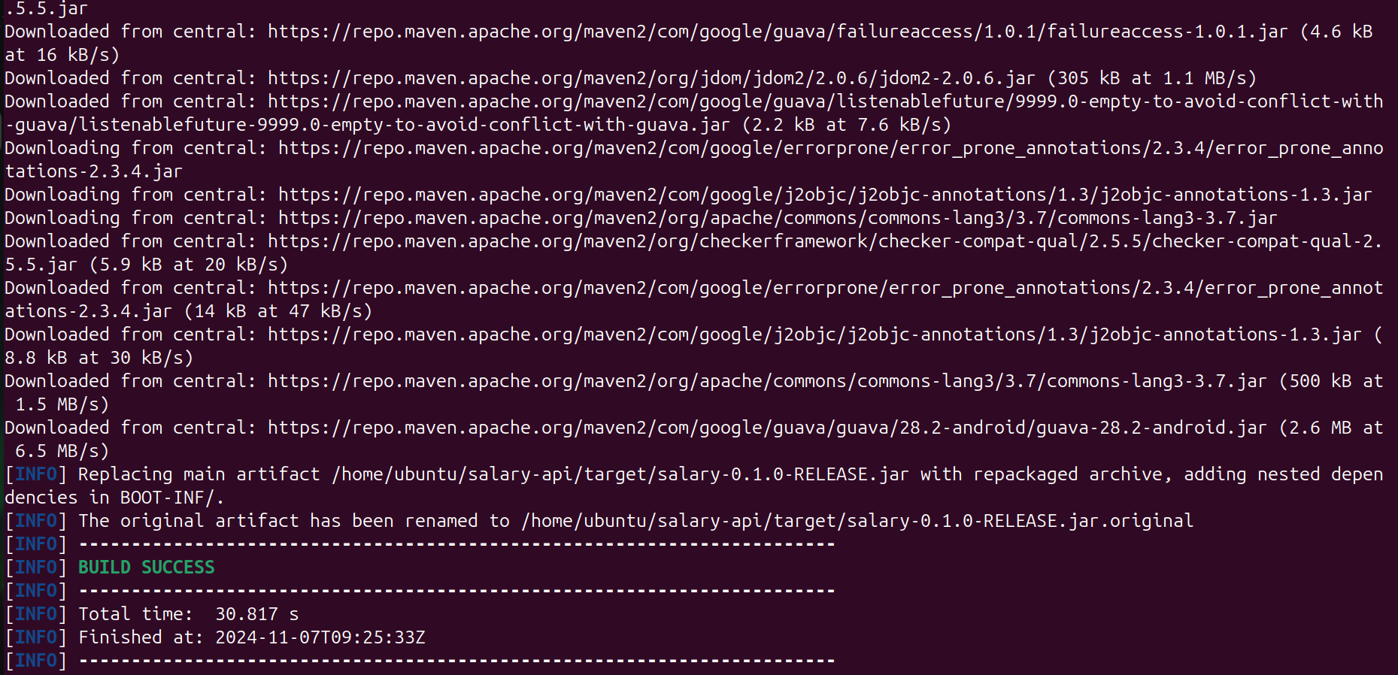

F) Install make command

**sudo apt install make**

G) Change the ip address into migration.json file in salary-api directory



F) Now run the migration command

**make run-migrations**

H) Finally run the java runtime command

**java -jar target/salary-0.1.0-RELEASE.jar**

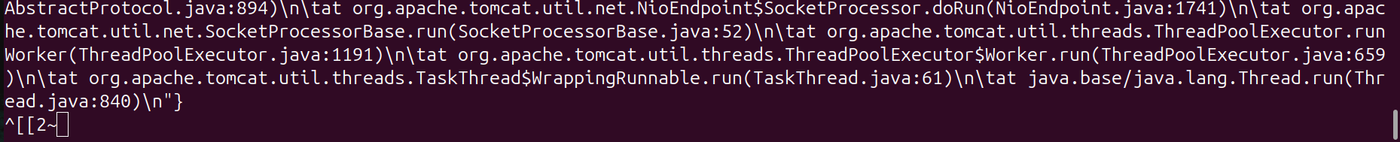

**FINAL OUTPUT**

